|  |  |
| --- | --- |
| CMSlogOIS.jpg | Centers for Medicare & Medicaid Services  CMS eXpedited Life Cycle (XLC) |

Physician Quality Reporting System (PQRS)/ Electronic Prescribing (eRx) Programs Electronic Survey for Registries

User Manual

Version 1.0

02/18/2014

**Document Number:** PQRSDV_ElectSurvey_UserGuide_v1_0_D_20140218.docx

**Contact Number:** HHSM-500-2013-00160C

Table of Contents

1. Introduction 4

1.1 Purpose of this Document 4

1.2 Intended Audience of this Document 4

2. Overview 4

2.1 Conventions 7

3. Getting Started 7

3.1 Set-up Considerations 7

3.2 User Access Considerations 7

3.3 Accessing the System 8

3.4 Survey Organization & Navigation 8

3.5 Exiting the System 8

4. Using the System 8

4.1 Survey Home Page 8

4.1.1 CMS.gov / Physician Quality Reporting System (PQRS) 10

4.2 User Survey 11

4.3 Survey Help 11

4.3.1 Survey User Guide 11

5. Troubleshooting & Support 11

5.1 Error Messages 11

5.2 Special Considerations 12

5.3 Support 12

Appendix 13

Acronyms 16

Glossary 18

Referenced Documents 19

Record of Changes 20

Approvals 21

List of Figures

Figure 1: Survey Administration Graphic Depiction…………………………………………5

Figure 2: Survey User Graphic Depiction…………………………………………………….6

List of Tables

Table 1: Survey Categories 7

Table 2: Support Points of Contact 8

Table 3: Acronyms 12

Table 4: Record of Changes 14

# Introduction

The Physician Quality Reporting System (PQRS)/Electronic Prescribing (eRx) Programs Electronic Survey (Survey) for Registries was developed under CMS’ guidance as they continue to work towards improving data quality from the Registry reporting option for the PQRS and eRx programs. The survey is a data collection tool to facilitate the identification, creation and deployment of process improvements, as well as the development of data quality recommendations for CMS, as the agency moves towards value based purchasing and as they expand public reporting of performance information on Physician Compare.

## Purpose of this Document

This User Guide provides users with the information necessary to complete an electronic survey to include logging in, navigating within the survey application, and submitting a final survey.

## Intended Audience of this Document

The intended audience for this document is users who are responsible for the compilation and submission of data using the Registry reporting option for the PQRS and eRx programs.

**1.3 Document Security Considerations**

There are no privacy or security concerns for this document because it does not contain any Personally Identifiable Information (PII).

# Overview

The Survey is a web-based application that has a design predicated upon role-based access. Roles are defined according to job competency, authority, and responsibility. Within the application, the following roles exist:

• Administrator

• Survey User

• Reports User

This design enables users to carry out a wide range of authorized tasks by dynamically regulating their actions according to flexible functions, relationships, and constraints. Roles can be easily created, changed, or discontinued as the needs of the enterprise evolve, without having to individually update the privileges for every user. At a high level, this means that the amount of functionality available to the Survey Administrator would be different from the functionality available to a Survey User. The following diagrams depict the functionality for each, thus making it “role-based”.

**Figure 1: Survey Administration Graphic Depiction**

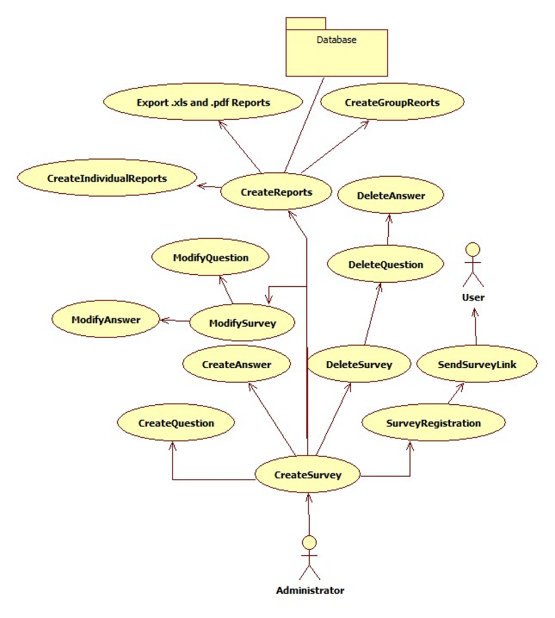

**Figure 2: Survey User Graphic Depiction**

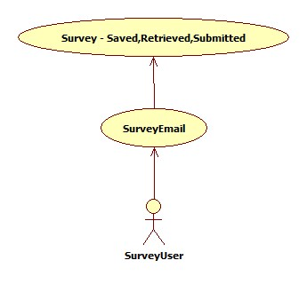

This User Guide is specific to the features and functionality associated with the Survey User role.

Users from Registries will access the Survey via a link provided in the invitation email – a system login is not required nor is personal information such as name, phone number, or email address collected. The Survey will, however, display the Registry’s contact details, as they are listed in the Qualified Registries for the 2012 Physician Quality Reporting System (PQRS) and Electronic Prescribing (eRx) Incentive Programs Report, and the user will be asked to validate the information. If any of the information is incorrect, they are asked to contact the survey administrator at surveyadmin@archsystemsinc.com so the appropriate corrections can be made.

The Survey will use a series of questions, arranged by category, to gather information about data handling practices, training and quality assurance, as well as stakeholder perceptions of challenges faced when participating in the program.

**In order to assurance HIPAA compliance, please do not include any Personally Identifiable Information (PII) in your survey responses.**

The categories of questions contained within the Survey, and a description of each, are described in Table 1.

|  |  |
| --- | --- |
| **Category** | **Description** |
| Corporate Information | Displays demographic information currently on file for the Registry such as Company Name, Address and Telephone Number. |
| Training | The type of training provided to individuals responsible for transmitting the data. |
| Data Handling | Processes for data collection and transmission. |
| Quality Assurance | The validation and verification steps completed prior to data transmission. |
| eRx | Processes for data collection and transmission. |
| Feedback | User feedback regarding specific components of the Program. Free-form text is permitted. |

**Table 1: Survey Categories**

The data collected through the completed surveys will be compiled, analyzed and provided to CMS as a report. CMS will in turn use this information to improve data quality from the Registry reporting option for the PQRS and eRx programs through the identification, creation and deployment of process improvements and data quality initiatives.

## Conventions

The Survey was designed with simplicity as a core requirement. It provides consistency among the various screens and does not require use of proprietary function keys, codes, and mnemonics that must be memorized by users to efficiently interact with the system.

# Getting Started

The following sections describe system requirements for accessing the survey application.

## Set-up Considerations

CMS screens are designed to be viewed at a minimum screen resolution of 800 x 600. To optimize your access to the Electronic Survey screen resolution should be set to 1024 x 768 or higher.

Access to the Internet is required as the Electronic Survey is a web-based application. The following Internet browsers are compatible for the Electronic Survey:

* Internet Explorer, version 8.0 or higher
* Mozilla Firefox
* Chrome

## User Access Considerations

There are no special user access considerations.

## Accessing the System

Users from Registries will access the Survey via a link provided in the invitation email that will be sent by the Survey Administrator – a system login is not required nor is personal information such as name, phone number or email addressed collected.

## Survey Organization & Navigation

The CMS Physician Quality Reporting System (PQRS)/Electronic Survey for Registries site has three (3) pages:

* Home Page
* User Survey
* Help

A tab-based system is employed to navigate between the Survey module pages as well as the User Survey Categories.

The Home and Help pages are informational pages with embedded hyperlinks.

The User Survey page is an interactive page with a tab-based system for navigating between 6 question categories.

## Exiting the System

Users may exit the Survey by closing the application in their browser at any time. Survey Users should answer all questions before clicking “Submit Survey.”

Users can save their responses, exit the survey, and return to the Survey at a later time. However, the Survey will be closed once a User has clicked “Submit Survey.”

Users who unintentionally submit their Survey should contact the Survey Administration ([surveyadmin@archsystemsinc.com](mailto:Surveyadmin@archsystemsinc.com)) as soon as possible.

# Using the System

Survey Users Home page when accessing the link in the Survey invitation, login is not required. Users navigate between the three Survey pages.

## Survey Home Page

The Survey Home Page features the CMS logo, a statement about the Survey, and the Survey timeline. A link is embedded within the CMS logo that will take the user to the CMS.gov Physician Quality Reporting System (PQRS) webpage.

**Figure x: Survey Home Page**



**Figure x: Survey Home Page, view 2**

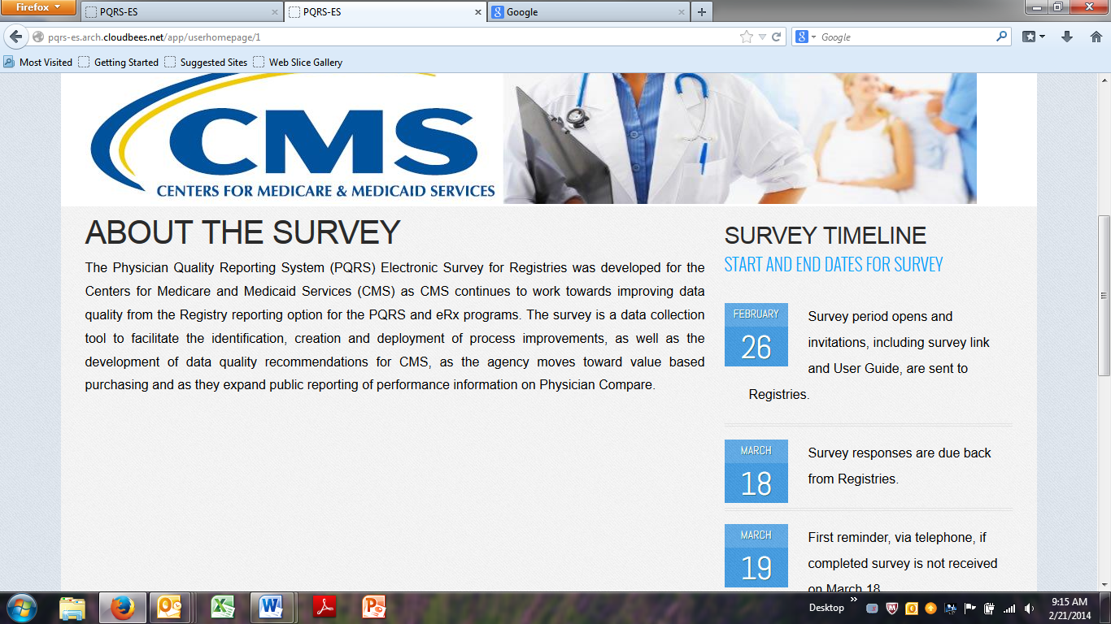

### CMS.gov / Physician Quality Reporting System (PQRS)

To access the PQRS page on the CMS website, place your curser over the CMS logo and click. Your browser will be re-directed to the CMS website.

**Figure x: Accessing CMS.gov PQRS**



To return to the Survey, click the back arrow at the top of your browser. You will be returned to the Survey Home Page.

**Figure x: CMS.gov PQRS**

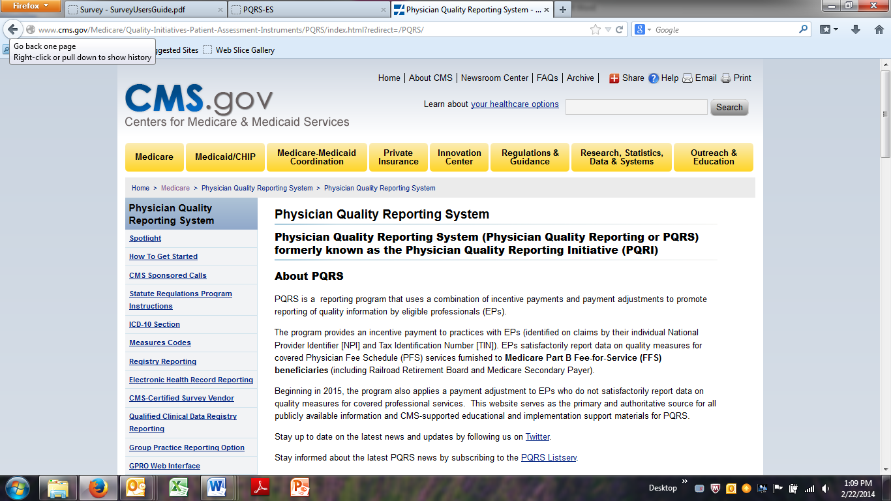

## User Survey

The User Survey page has 6 questions tabs. The User verifies that the Registry demographic information is correct on the Corporate Information tab before processing through the five subsequent tabs to complete the Survey. The Survey will not include the eRx Survey questions For Registries that did not participate in the Electronic Prescribing (eRx) Program. Please verify that this information is correct in the Corporate Information section. The Survey sections are:

* Corporate Information
* Training Information
* PQRS Data Handling
* Quality Assurance
* eRx
* Feedback

## 4.2.1 Completing the Survey

## Corporate Information

After verifying the Registry information as it appears on the Corporate Information tab, the user clicks “Start Survey” on the bottom left of the Corporate Information section.

**Figure x: User Survey Opening Page**

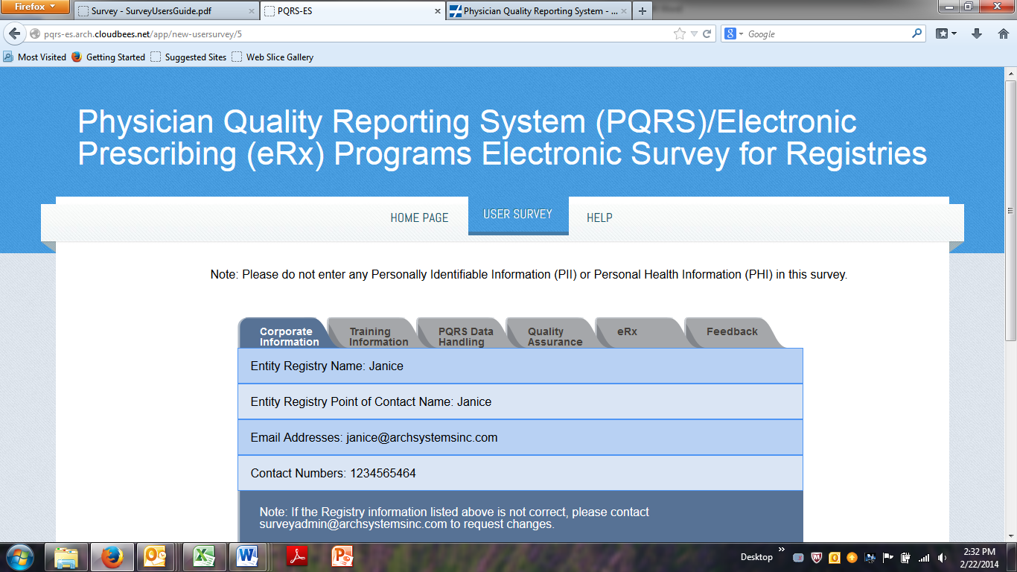

After verifying the Registry information as it appears on the Corporate Information tab, the user clicks “Start Survey” on the bottom left of the Corporate Information section. If the user closes the Survey application before completing the Survey, this button will appear as “Restart Survey” when the User returns to the Survey.

**Figure x: Start Survey**

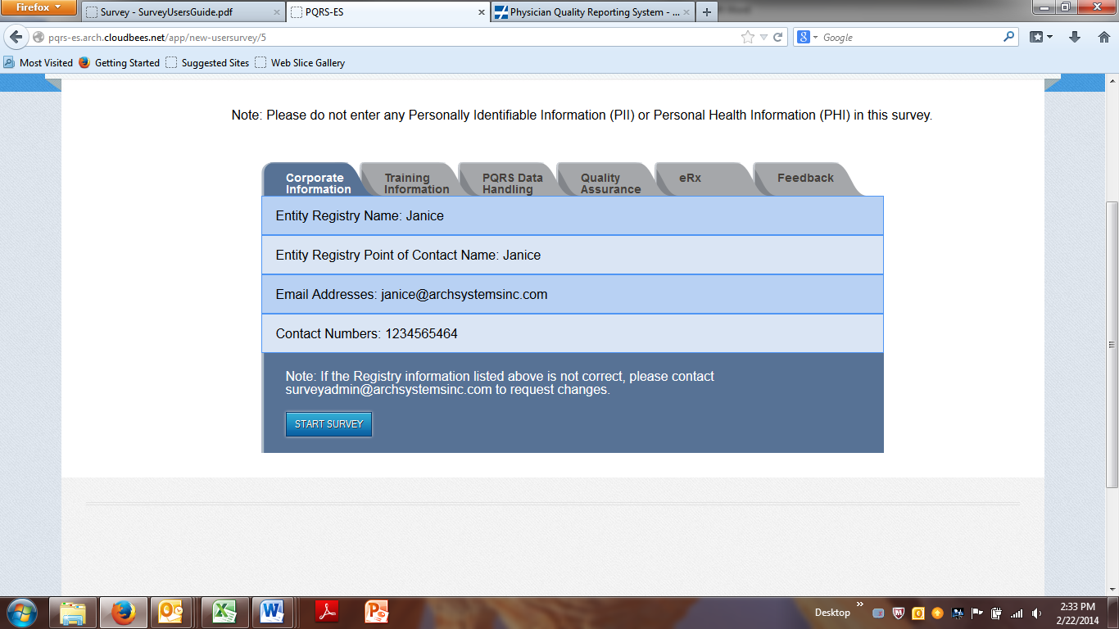

## Completing Questions

The Survey includes a variety of question types:

* Multiple Choice
* Yes/No
* Free Text Responses

Depending on the type of question, the User may select from response options listed in the Survey or provide a descriptive response in a blank text box. Certain questions have both User selection and a blank text box.

**Multiple Choice Questions:** The Survey has 2 types of Multiple Choice questions.

**Single Option Multiple Choice:** A drop down box appears for questions for which only one response is permitted.

To select a response from the drop down, click the arrow to the right of “Select”. Response options appear. Click on the desired response (see figure x: Selecting from a Drop Down).

**Figure x: Selecting From a Drop Down**

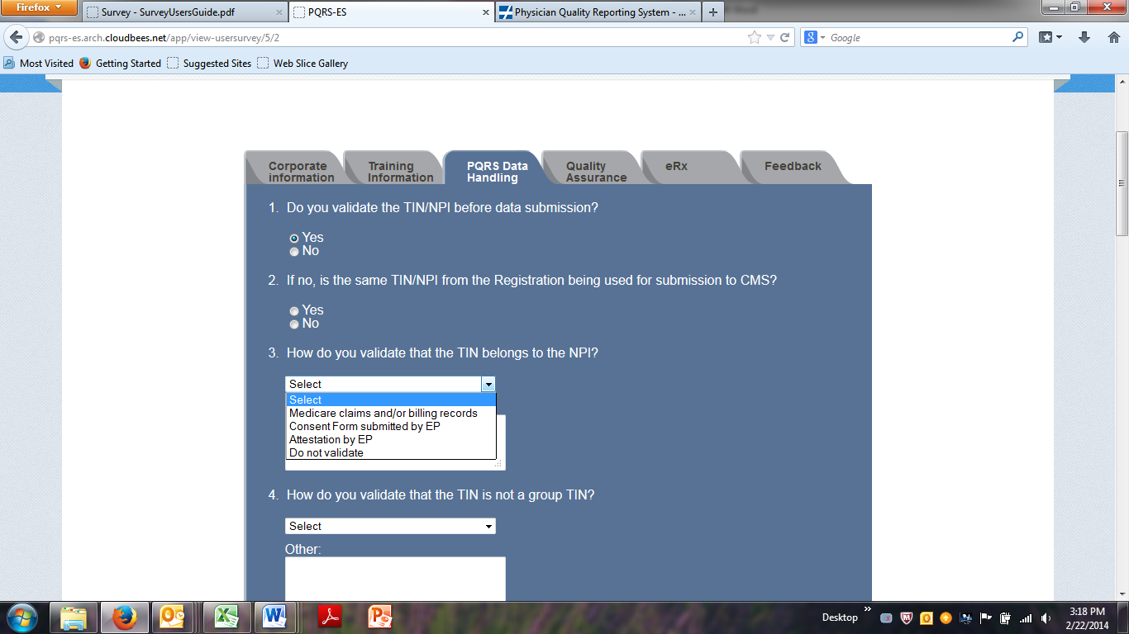

**Multiple Option Multiple Choice Questions:** Multiple response options appear in the box, along with an up or down scroll to the right side of the box.

To provide a single response to this type of Multiple Choice question, place the curser over your selection and click using your mouse or keyboard.

To provide more than one response to this type of Multiple Choice question, hold down the CTRL button on your keyboard, place the cursor over each selection and click for each desired response.

**Figure x: Completing Multiple Choice Questions**

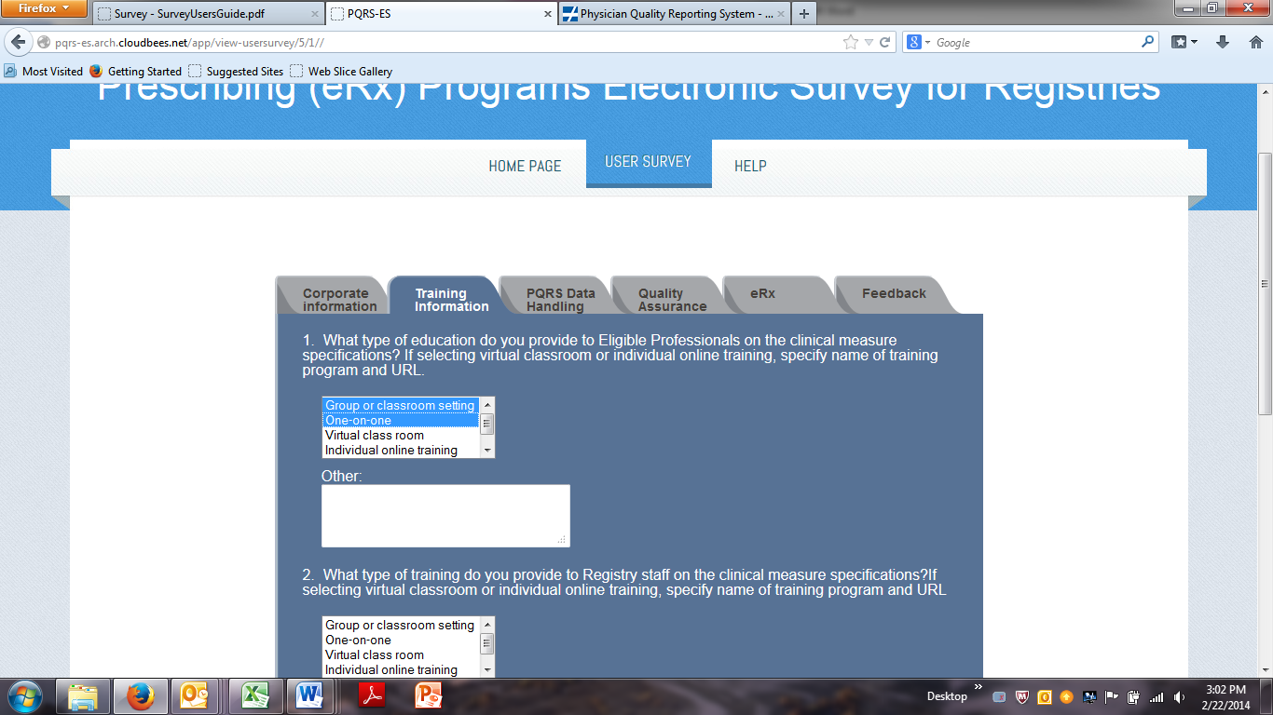

**Yes/No Check Box Questions:** Questions with yes, no or N/A (not applicable) response options have a check box from which to make a selection.

Place the curser over the circle next to the desired answer and click.

**Figure x: Completing Check Box Question**

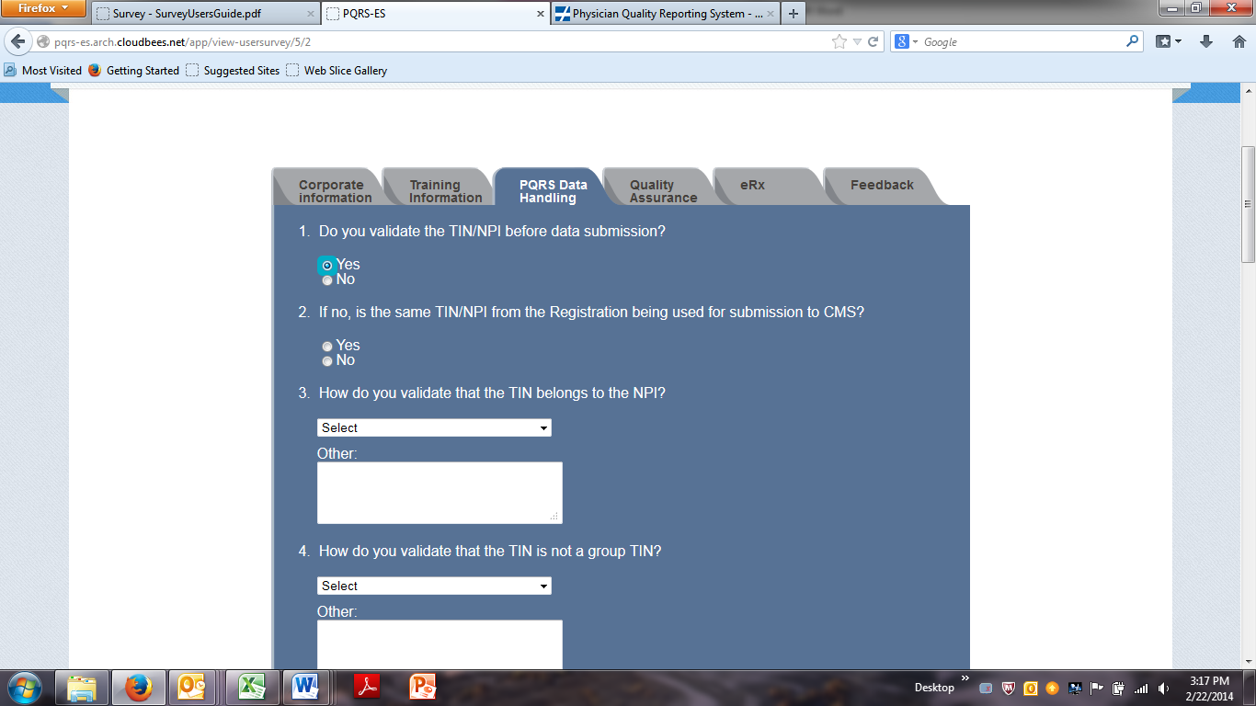

**Descriptive Text Responses:** Text boxes are provided for the User to enter a descriptive response. These boxes are provided for open-ended questions, such as appear on the Feedback tab (see Figure x: Free Text Descriptive Response Box), as well as for Multiple Choice questions for which an additional response is desired.

**Figure x: Free Text Descriptive Response Box**

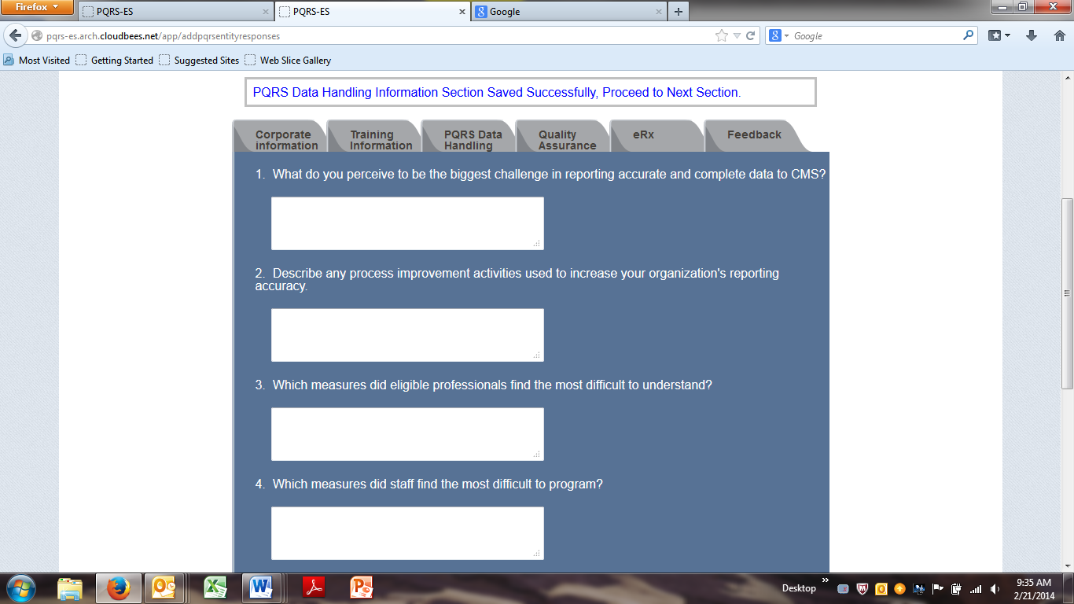

## Survey Help

The Survey Help page can be reached from any Survey view. The Help page contains a Contact Support statement informing the User how to obtain technical support for the Survey. The Help page also has a link to the Survey User Guide.

### Survey User Guide

The User can access an electronic version of the Survey User Guide by clicking the question mark that appears in the blue oval on the right side of the page next to the Contact Support statement.

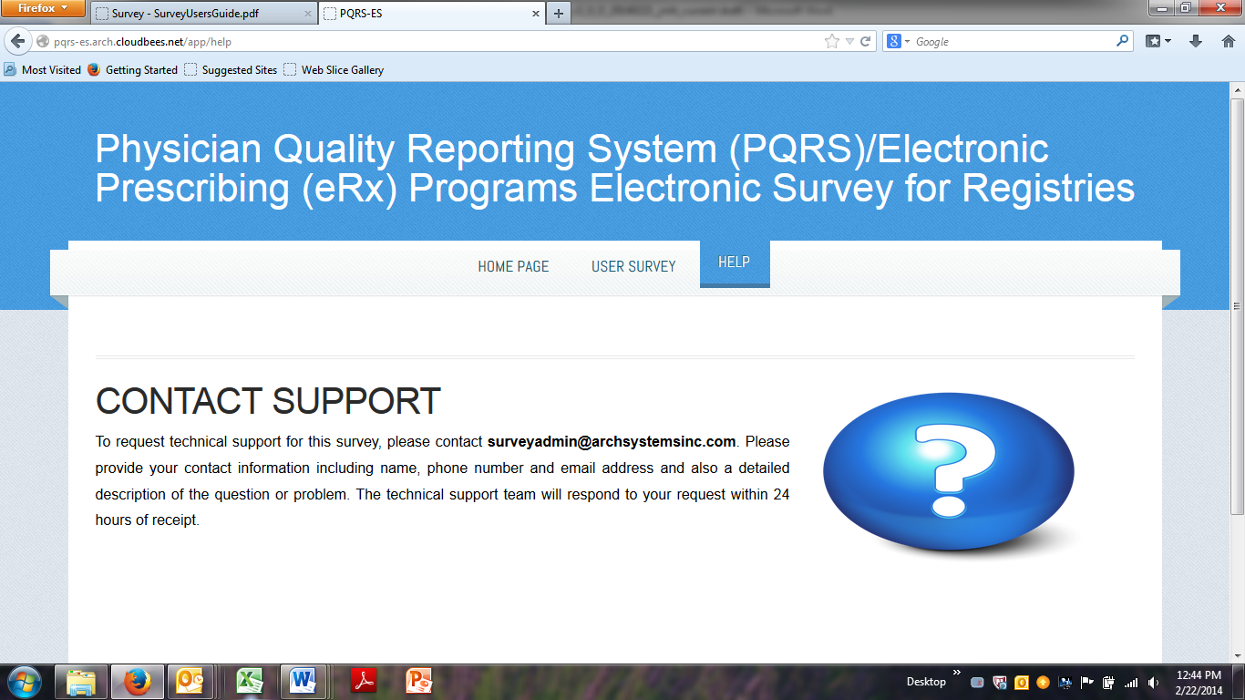

# Troubleshooting & Support

## Error Messages

* **Save and Next Section Error Message**

The Survey requires that users answer all questions in a section before saving and moving to the next section. The following error message will appear if the user clicks the “Save and Next” button before completing all questions in a section:

**"Please provide all the answers before proceeding to the next section."**

The user may navigate between question tabs without completing all questions in a section and the User may exit the Survey before answering all questions without receiving an error message.

* **Submit Survey Error Message**

The Survey requires that users answer all questions before submitting.” The following error message will appear if the user clicks the “Submit Survey” button before completing questions in all sections:

**“You must enter all survey questions before submitting the survey. Please complete any unanswered questions and then submit.”**

## Special Considerations

Not applicable.

## Support

* Technical Support: To request technical support for this survey, users can email: surveyadmin@archsystemsinc.com and request assistance. Users should include their name, phone number, and email address and also a detailed description of the question or problem. The mailbox is monitored from 7:00 am to 7:00 pm EST, Monday through Friday. The technical support team will respond to your request within 24 hours of receipt.
* User Guide: the User Guide is made available electronically on the Help tab of the survey. Users can refer to the guide for assistance with issues involving navigation, system requirements, etc.

Appendix

Appendix 1: Survey Questions

1. **Training**
2. What type of education do you provide to **Eligible Professionals** on the clinical measure specifications?

Check all that apply:

* Group or classroom setting.
* One-on-one.
* Virtual class room.
* Individual online training.
* If selecting virtual classroom or individual online training, specify name of training program and URL. [Needs Text Box also]
* Other
* Do not train staff

1. What type of training do you provide to **Registry staff** on the clinical measure specifications? Check all that apply:

* Group or classroom setting.
* One-on-one.
* Virtual class room.
* Individual online training.
* If selecting virtual classroom or individual online training, specify name of training program and URL. [Needs Text Box also]
* Other
* Do not train staff

1. **PQRS Data Handling**
2. Do you validate the TIN/NPI before data submission? Yes/No
3. If no, is the same TIN/NPI from the Registration being used for submission to CMS? Yes/No
4. How do you validate that the TIN belongs to the NPI?
   1. Medicare claims and/or billing records
   2. Consent Form submitted by EP
   3. Attestation by EP
   4. Do not validate
   5. Other - describe
5. How do you validate that the TIN is not a group TIN?
   1. Medicare claims and/or billing records
   2. Consent Form submitted by EP
   3. Attestation by EP
   4. Do not validate
   5. Other - describe
6. How do you validate that the NPI is the individual NPI?
   1. NPPES search
   2. Medicare claim and/or billing records
   3. Other
7. What external source do you use to validate the TIN/NPI combination?
   1. Medicare claims and/or billing records
   2. Consent Form submitted by EP
   3. Do not validate
   4. Other – describe
8. Does your registration system allow for TIN/NPI updates during the Program year but before data submission? YES/NO

7a. If yes, do you validate the updated TIN/NPI combination before data submission? Yes/No/NA

1. Do you have an automated abstraction tool to support EPs using manual chart abstraction for reporting clinical quality data? Yes/No

8a. If yes, can the EPs verify the accuracy of their data in your system before submission to CMS? Yes/No/NA

1. For EPs with non-EHR/PMS systems, do you conduct randomized audits of the data submitted by the EPs? Yes/No
2. Do you update abstraction and data collection tools on an annual basis to comply with Program requirement changes? Yes/No
3. Each year, do you test your XML file using the SEVT tool? Yes/No

11a. If yes, do you still encounter issues during data submission to CMS? Yes/No/NA

1. If you do not test your XML file using the SEVT tool, do you validate the data contained in the XML file before submission to CMS? Yes/No
2. During data collection, do you have a process for checking for data anomalies? Yes/No
3. How do you provide data collection and/or data submission support to your EPs?
   1. Help Desk
   2. Phone/Email
   3. No Support
4. **Quality Assurance**
5. Do you provide feedback reports to EPs? Yes/No
6. If yes, are the reports generated by measure? Yes/No
7. **eRx**
8. What training did you provide to your Registry staff responsible for submitting results for the eRx Incentive Program?

Check all that apply:

* Group or classroom setting.
* One-on-one.
* Virtual class room.
* Individual online training.
* If selecting virtual classroom or individual online training, specify name of training program and URL. [Needs Text Box also]
* Other
* Do not train staff

1. Do you have a process in place to verify that a qualified electronic prescribing (eRx) system was in place prior to eligible professionals (EPs) meeting the eRx incentive program requirements? Yes/No
2. Did you conduct an audit to ensure that the system is being used to generate and transmit an electronic prescription when the G-code G8553 is being reported? Yes/No

**Feedback**

|  |
| --- |
| 1. What do you perceive to be the biggest challenge in reporting accurate and complete data to CMS? 2. Describe any process improvement activities used to increase your organization’s reporting accuracy. 3. Which measures did eligible professionals find the most difficult to understand? 4. Which measures did staff find the most difficult to program? |

*.*

Acronyms

|  |  |  |
| --- | --- | --- |
| **Acronym** | **Literal Translation** | **Definition** |
| CMS | Centers for Medicare and Medicaid Services | CMS is a Federal agency within the United States Department of Health and Human Services that administers the Medicare program and works in partnership with state governments to administer Medicaid, the State Children’s Health Insurance Program, and health insurance portability standards. |
| EP | Eligible Provider | Designation given to providers who are eligible to participate in the Physician Quality Reporting Program. |
| eRx | eRx | The Medicare Electronic Prescribing Incentive Program. |
| EST | Eastern Standard Time | The time zone within which administrative support is available for the Survey. |
| GPRO | Group Practice Reporting Option | A new group practice reporting option (GPRO) for the Electronic Prescribing (eRx) Incentive Program beginning with the 2010 eRx Incentive Program. |
| NCH | National Claims History | CMS System of Record (SOR). The primary purpose of this modified system is to collect and maintain billing and utilization data on Medicare beneficiaries enrolled in hospital insurance (Part A) or medical insurance (Part B) of the Medicare program for statistical and research purposes related to evaluating and studying the operation and effectiveness of the Medicare program. |
| NPI | National Provider Identifier | An NPI is a unique 10-digit identification number issued to health care providers in the United States by Centers for Medicare & Medicaid Services. Covered health care providers and all health plans and health care clearinghouses must use the NPI in the administrative and financial transactions adopted under Health Insurance Portability and Accountability Act. |
| PDF | Portable Document Format | A file format used to represent documents in a manner independent of application software, hardware, and operating system. |
| PHI | Personal Health Information | Personal health information (PHI), also referred to as protected health information, generally refers to demographic information, medical history, test and laboratory results, insurance information and other data that is collected by a health care professional to identify an individual and determine appropriate care. |
| PII | Personally Identifiable Information | PII is information that identifies or describes an individual, including but not limited to name, address, telephone number, social security number, credit card number, and personal characteristics that make the individual’s identity easily discoverable. |
| PQRS | Physician Quality Reporting System | PQRS is a reporting program that uses a combination of incentive payments and payment adjustments to promote reporting of quality information by eligible professionals (EPs). |
| SOR | System of Record | An information storage system that is the authoritative data source for a given data element or piece of information. |
| SR | Service Request | An SR is used within CMS to initiate work. |
| TIN | Taxpayer Identification Number | A TIN identifies entities for tax-related purposes such as filing tax returns, or other actions such as opening a bank account. |
| VPN | Virtual Private Network | A VPN is a network set up for use by a limited number of individuals, such as employees of a company, operating over a large area. The network typically uses encryption to keep information secure. |
| XML | Extensible Markup Language | XML is a set of rules for encoding documents in a machine-readable format. |

Table x: Acronyms

Glossary

See Acronyms above

Referenced Documents

Not Applicable

Record of Changes

Instructions: Use the table below to record information regarding changes made to the document over time.

| Version  Number | Date | Author/Owner | Description of Change |
| --- | --- | --- | --- |
|  |  |  |  |
|  |  |  |  |
|  |  |  |  |
|  |  |  |  |
|  |  |  |  |
|  |  |  |  |
|  |  |  |  |
|  |  |  |  |
|  |  |  |  |
|  |  |  |  |
|  |  |  |  |
|  |  |  |  |

Table 5: Record of Changes

Approvals

Instructions: Obtain signature approval of the final document from the delivering organization’s Approving Authority, the primary CMS recipient (i.e., generally the Government Task Leader (GTL), and the Business Owner. Additional signature lines may be added as needed.

The undersigned acknowledge that they have reviewed the User Manual and agree with the information presented within t his document. Changes to this User Manual will be coordinated with, and approved by, the undersigned, or their designated representatives.

|  |  |  |  |
| --- | --- | --- | --- |
| Approval Signatures | | | |
| Signature: | Enter your signature | Date: | Enter date |
| Print Name: | Enter your name | | |
| Title: | Enter your title | | |
| Role: Submitting Organization’s Approving Authority | | | |
| Signature: | Enter your signature | Date: | Enter date |
| Print Name: | Enter your name | | |
| Title: | Enter your title | | |
| Role: CMS Approving Authority | | | |
| Signature: | Enter Your Signature | Date: | Enter date |
| Print Name: | Enter your name | | |
| Title: | Enter your name | | |
| Role: CMS Business Owner | | | |